Name: Aditya Nalini

Registration Number: 19BCE0980

Lab Activity 4

Q.

Design the following fields in HTML and CSS(use Box model) document using proper JAVA Script regular expression. (Do not use HTML Pattern attribute)

Design the regular expression with the following conditions and test it. If not satisfied throw alert and prompt user to correct it.

Make all the fields to be required using HTML5.

username : minimum 8 chars

Password : Strong ( 16chars length, min 1 small character, min 1 capital char, min 1 digit)

Confirm password should match the normal password

Email : min one @ symbol

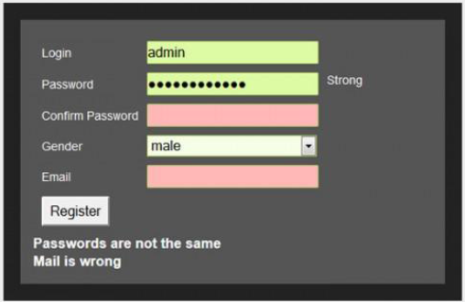

Code:

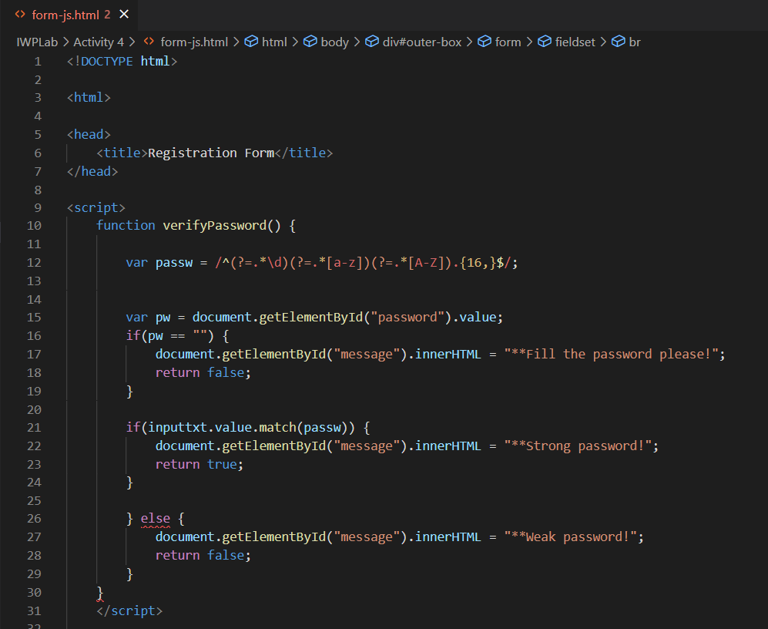

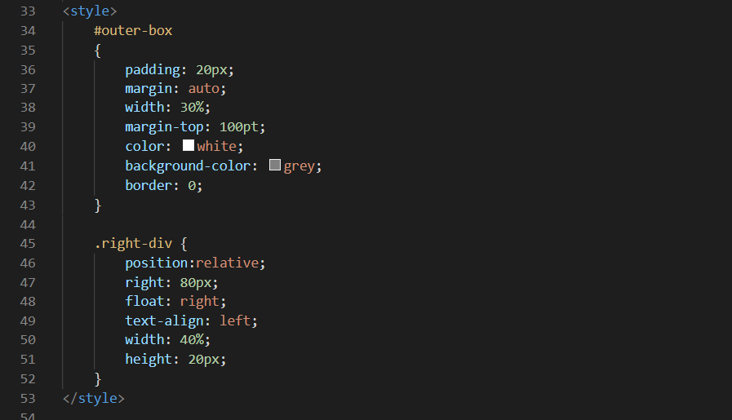

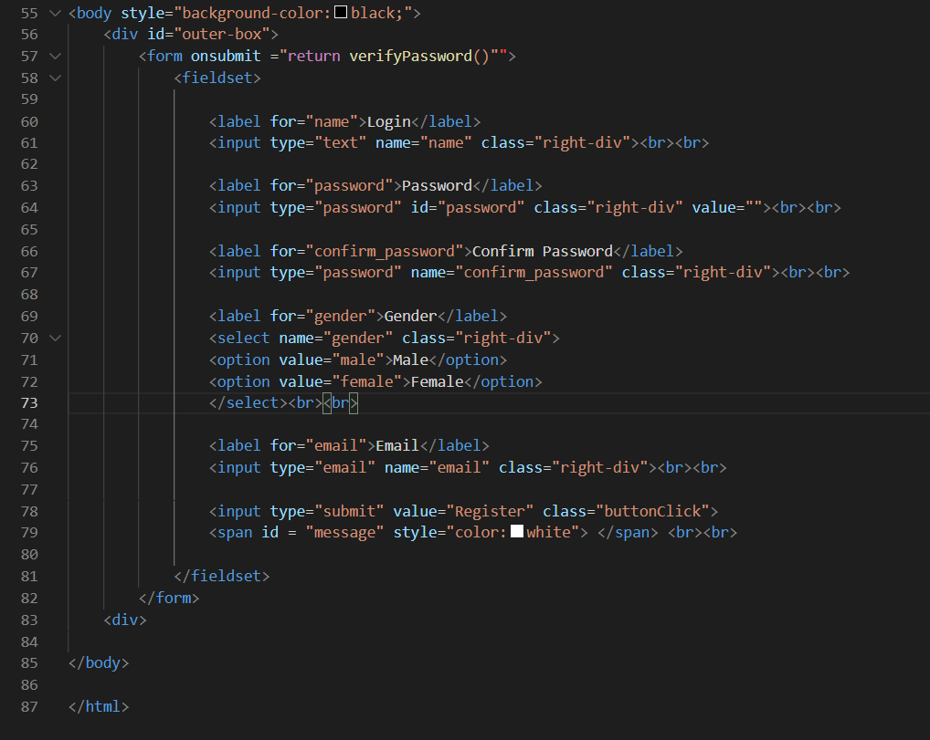

<!DOCTYPE html>

<html>

<head>

<title>Registration Form</title>

</head>

<script>

function verifyPassword() {

var passw = /^(?=.*\d)(?=.*[a-z])(?=.*[A-Z]).{16,}$/;

var pw = document.getElementById("password").value;

if(pw == "") {

document.getElementById("message").innerHTML = "**Fill the password please!";

return false;

}

if(inputtxt.value.match(passw)) {

document.getElementById("message").innerHTML = "**Strong password!";

return true;

}

} else {

document.getElementById("message").innerHTML = "**Weak password!";

return false;

}

}

</script>

<style>

#outer-box

{

padding: 20px;

margin: auto;

width: 30%;

margin-top: 100pt;

color: white;

background-color: grey;

border: 0;

}

.right-div {

position:relative;

right: 80px;

float: right;

text-align: left;

width: 40%;

height: 20px;

}

</style>

<body style="background-color:black;">

<div id="outer-box">

<form onsubmit ="return verifyPassword()"">

<fieldset>

<label for="name">Login</label>

<input type="text" name="name" class="right-div"><br><br>

<label for="password">Password</label>

<input type="password" id="password" class="right-div" value=""><br><br>

<label for="confirm_password">Confirm Password</label>

<input type="password" name="confirm_password" class="right-div"><br><br>

<label for="gender">Gender</label>

<select name="gender" class="right-div">

<option value="male">Male</option>

<option value="female">Female</option>

</select><br><br>

<label for="email">Email</label>

<input type="email" name="email" class="right-div"><br><br>

<input type="submit" value="Register" class="buttonClick">

<span id = "message" style="color:white"> </span> <br><br>

</fieldset>

</form>

<div>

</body>

</html>

Output:

